PROJECT REPORT

ON

ANALYSIS OF ATRIUM HEALTH’S HOSPITAL AT HOME PROGRAM
A Case-Based Comparative Study of Software Development Life Cycle Models in Healthcare

Submitted to

NMAM INSTITUTE OF TECHNOLOGY, NITTE
(Off-Campus Centre, Nitte Deemed to be University, Nitte - 574 110, Karnataka, India)

In partial fulfillment of the requirements for the award of the

Degree of Bachelor of Technology

in

INFORMATION SCIENCE AND ENGINEERING

By

AMAN HEGDE | NNM24IS019

Under the guidance of

Dr. JASON ELROY MARTIS
Associate Professor


2025 – 2026

Introduction

# Background

Atrium Health's Hospital at Home Program stands as a healthcare revolution that offers top-quality healthcare through at-home services for its patients. Atrium Health has created a program, which combines administrative tasks and clinical needs to deliver exceptional care in patient homes without admitting them to hospital facilities. Atrium Health serves as the leading healthcare organization in implementing virtual care and remote patient monitoring as essential trends in today's healthcare sector.

# Objectives

This paper focuses on evaluating Atrium Health’s Hospital at Home Program through the Software Development Lifecycle (SDLC). Researchers need to examine how various software process models affect requirements management during comparative analysis. The assessment aims to determine which software development models will best suit this program by examining its specific needs along with the encountered difficulties.

# Scope: The scope of this report includes:
- A detailed overview of Atrium Health’s Hospital at Home Program.
- The research evaluates three product development models namely the Incremental model and Spiral model and Waterfall model.
- Comprehensive requirements engineering process.
- Integration of Agile, DevOps, and ethical considerations.
- Exploration of emerging technologies such as AI, IoT, and Block chain.
- Evaluation of additional SDLC models and frameworks.

# Methodology
The methodology involves:
- Literature review of existing SDLC models and their applications.
- Case study analysis of Atrium Health’s Hospital at Home Program.
- Comparison of the several models as to which of the program they are most appropriate for.
- Detailed requirements engineering process.
- Integration of emerging technologies and additional SDLC models.

Comparison and Analysis of Software Process Models

# Incremental Development Model
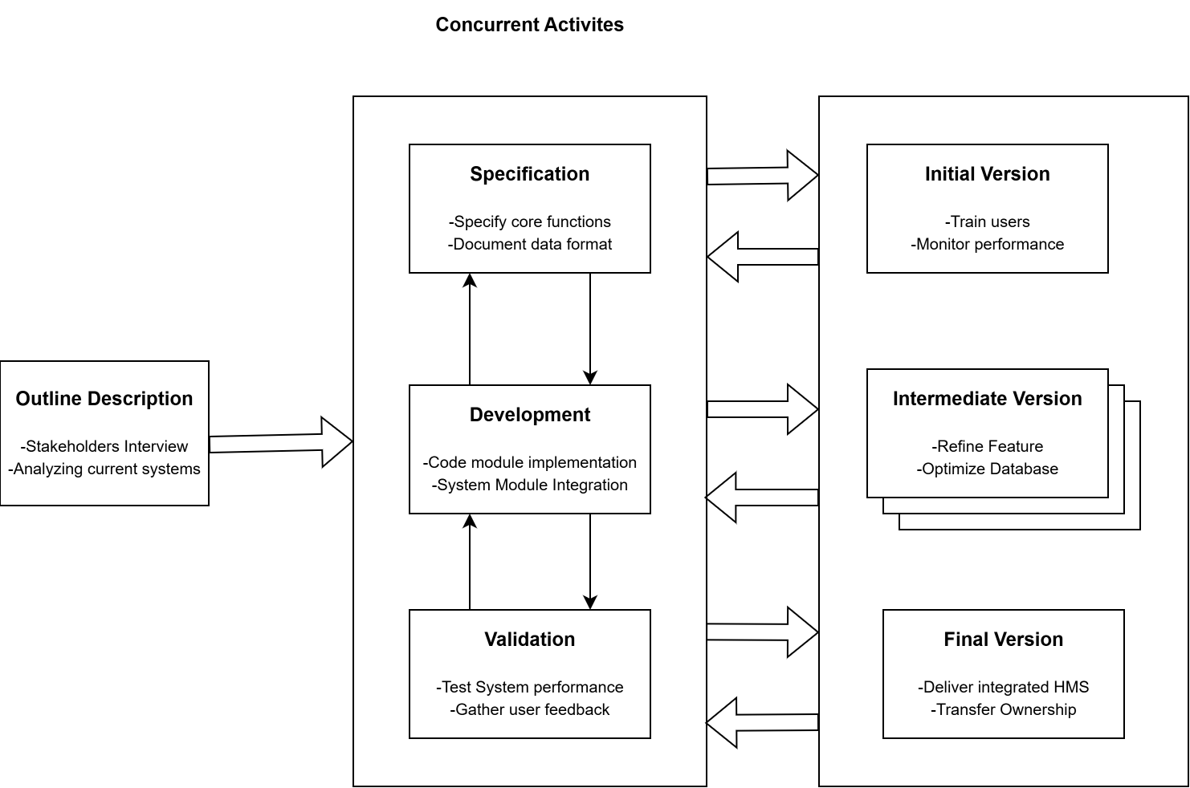

Suitability for Atrium Health’s Hospital at Home Program
- Functional Requirements: The model strategically introduces essential features within healthcare organizations, such as patient registration, appointment scheduling, and billing processes. Initially, critical functionalities are emphasized, followed by the integration of additional features to ensure a cohesive experience for healthcare providers.
- Non-Functional Requirements: A phased approach progressively incorporates elements such as performance, security, and compliance (e.g., HIPAA). Each development stage contributes to the enhancement of the system by satisfying non-functional criteria.
- Risk and Change Management: The Incremental Model facilitates user engagement throughout each phase, thereby minimizing defects and ensuring alignment with regulatory and legal frameworks.
- Time and Cost Constraints: The timely delivery of essential components of the system is accomplished through careful project segmentation, addressing the budgetary and scheduling demands of healthcare providers.

Advantages
- Adaptable to the changes in the requirement.

Disadvantages
- As more increments are added, it might become difficult to integrate them into the system.
- Requires a great deal of planning and management.

# Spiral Model:

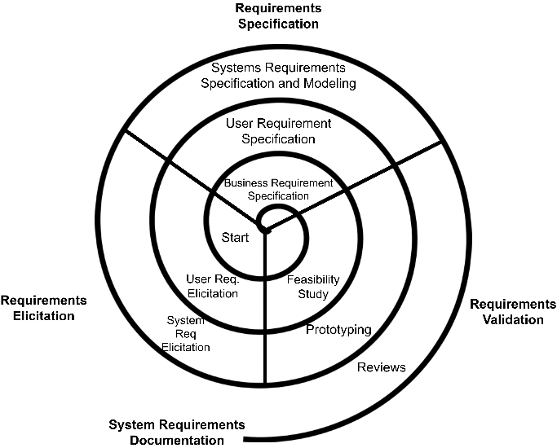

Spiral Model is a software development process model, which combines iterative and sequential approaches of software development. Spiral Model is highly appropriate for those projects with a complex, large size and high risk. The model promotes effective risk handling by embracing a cyclical iterative process with risk analysis and prototyping in each development phase.

Suitability for Atrium Health’s Hospital at Home Program
- Functional Requirements: The approach facilitates thorough testing of necessary patient confidentiality controls and regulatory requirements.
- Non-Functional Requirements: The system keeps on enhancing performance and security features along with reliability in a process of continuous improvement.
- Risk and Change Management: The system keeps on enhancing performance and security features along with reliability in a process of continuous improvement.
- Time and Cost Constraints: Costs are more upfront due to risk analysis and prototyping but the efforts reduce long-term risks and costly rework requirements.

Advantages
- Risk management is prioritized above all other considerations.
- The development process is subject to ongoing modifications.
- A quality product is assured through continuous validation and assessment.

Disadvantages
- Specialized human resources are essential for conducting risk analysis and prototyping.
- The process is time-intensive due to its iterative nature.

# Waterfall Model
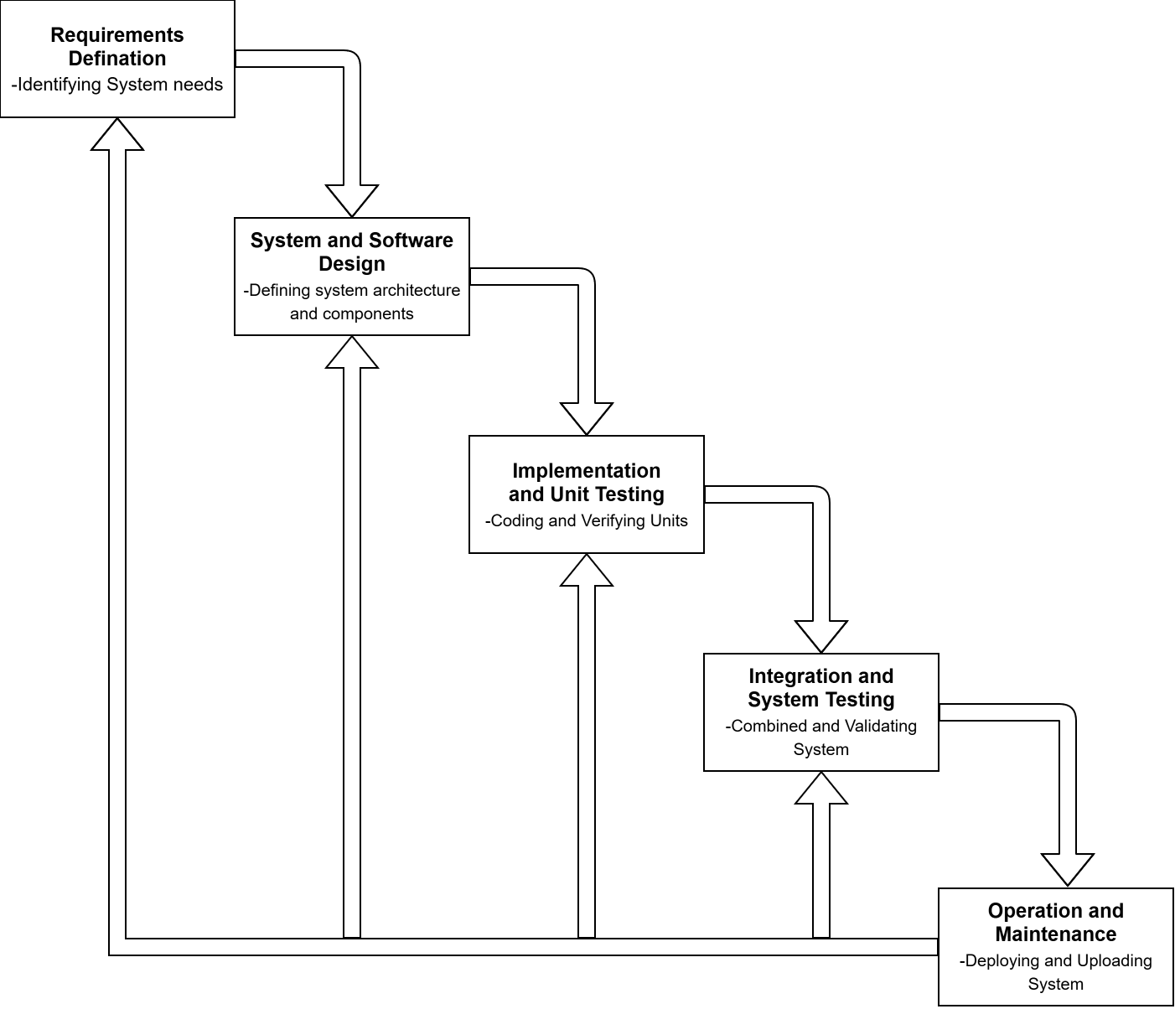

Suitability for Atrium Health’s Hospital at Home Program
- Functional Requirements: The system is designed to produce optimal results based on well-defined requirements that are expected to remain stable, such as the fundamental process of patient registration.
- Non-Functional Requirements: We are committed to thorough documentation and precise planning to ensure the system can be scaled for future enhancements while adhering to critical regulatory obligations and compliance criteria.
- Risk and Change Management: Once development commences, the system's flexibility to accommodate changes diminishes.
- Time and Cost Constraints: Effective project planning requires adherence to established timelines and budget restrictions; however, modifications initiated during development may result in escalated expenses.

Advantages
- Clear and concise communication.
- Projects that maintain comprehensive documentation will benefit from enhanced long-term maintainability due to readily available reference materials for future system updates.
- Effective for consistent requirements.

Disadvantages
- Incorporating essential changes post-development initiation presents challenges for this system.
- Product delivery may be delayed.
- Identifying issues later in the development phase becomes increasingly probable.

Summary for Comparison of All the Three Models
Aspect | Waterfall Model | Incremental Model | Spiral Model
Approach | Linear sequence | Develops in parts | Iterative with risk analysis
Flexibility | Low | Medium | High
Risk Management | Minimal | Moderate | High
User Involvement | Low | Medium | High

Requirements Engineering Process

# Simplified Requirements Document
Functional Requirements:
- Patient Registration and Management: The system facilitates efficient management of patient records, incorporating features for patient addition, as well as secure updates and deletions.
- Appointment Scheduling: This tool empowers patients to schedule appointments through various convenient methods, as well as modify or cancel existing appointments, thereby enhancing operational efficiency and user satisfaction.
- Billing and Payments: The system efficiently executes billing transactions and payment processes, while also managing insurance claims for accurate financial operations.
- Inventory Management: This platform monitors hospital medical supplies and equipment, systematically documenting data to prevent stock shortages and uphold operational workflows.
- Reporting: The system generates comprehensive data reports, which administrators and healthcare providers utilize to enhance decision-making capabilities and evaluate organizational performance.

Non-Functional Requirements:
- Security: The security protocols mandated by HIPAA regulations are prioritized to ensure the protection of sensitive patient data through robust security measures.
- Performance: The system is engineered to support performance levels accommodating up to 10,000 concurrent users. It features optimized software and hardware components that facilitate simultaneous operations while ensuring consistent system performance quality.
- Scalability: The system's architecture supports additional healthcare development needs through its design, allowing for the integration of extra modules, including telemedicine services. It offers flexible capabilities that enable operations to enhance their service area, adapting to increasing market demands while sustaining normal performance levels.
- Reliability: The system guarantees an uptime reliability of 99.9%, ensuring continuous accessibility for critical healthcare functions.
- Usability: Designed with a user-friendly interface, the system enhances usability for medical professionals and patients alike, facilitating straightforward interactions and minimizing the learning curve.

Requirements Elicitation Techniques
- Interviews: Individual interviews with healthcare professionals, including doctors, nurses, and administrators, are essential for identifying specific operational challenges and individual needs encountered on a daily basis. This approach facilitates the discovery of unique requirements pertinent to particular contexts.
- Surveys and Questionnaires: Structured surveys should be deployed to patients, caregivers, and other end-users to gather insights regarding desired system features and usability. This method enables the collection of valuable feedback on user preferences from a wide array of respondents.
- Workshops: The healthcare system will conduct workshops that convene interdisciplinary staff, hospital leadership, and healthcare providers to collaboratively establish and prioritize system requirements based on collective consensus.
- Observation: System observation enables personnel to pinpoint functional deficiencies within healthcare facilities, allowing the Healthcare Management System (HMS) to address these issues effectively. This first-hand perspective contributes to refining system requirements.
- Document Analysis: Analyzing system documentation along with industry standards and HIPAA regulations ensures that the Healthcare Management System adheres to legal requirements while effectively integrating with connected systems.

Requirements Validation Strategy
- Stakeholder Engagement Sessions: Hospital staff will facilitate ongoing engagement sessions to assess organizational requirements, ensuring alignment with stakeholder expectations through collaborative discussions.
- Prototype Development: The development team will produce realistic prototypes for stakeholders to engage with, enabling swift identification and refinement of requirement-related concerns.
- Real-World Use Case Simulations: Conducting simulations of actual scenarios will evaluate the system’s performance, instilling confidence in its suitability for healthcare operations.
- Requirements Traceability Matrix: A traceability matrix will be established to align requirements with design specifications and test cases, allowing for comprehensive reviews and reducing the risk of overlooked features.

Potential Challenges
- Diverse Stakeholder Expectations: Conflicts may arise from varying expectations among healthcare providers, administrative teams, and patients. Effective communication and collaborative decision-making are essential in addressing these needs.
- Shifting Regulatory Landscape: Medical practices must comply with stringent regulatory standards, such as HIPAA. Emerging regulations during the development process can result in delays and necessitate additional resources to ensure compliance.
- Unclear Specifications: Ambiguous requirements can often lead to system failures. Robust documentation, stakeholder endorsement, and iterative improvements are vital for achieving clarity.
- Resource Limitations: Limited access to skilled personnel, compressed timelines, and constricted budgets may impede development. Strategic resource allocation, prioritizing core features, and leveraging automated systems can help alleviate these challenges.

Overcoming Challenges

Addressing these challenges necessitates maintaining precise and continuous communication with stakeholders. Engaging end-users through collaborative tools during the validation process ensures that the system aligns with stakeholder expectations. Experienced analysts responsible for requirement documentation and management significantly reduce ambiguity throughout the process.

# Expanding SDLC Considerations

Agile Methodology in Healthcare Management
The integration of rapid development phases along with collaborative teamwork inherent in Agile methodology enhances the value of SDS model analyses for Health Management Systems (HMS). It is imperative for healthcare administrators to prioritize telemedicine integration and the management of COVID-19 vaccinations within the individual development cycles of their projects.
Advantages of Agile for HMS:
- Improved collaboration with stakeholders.
- Accelerated delivery of functional components.
- Implementing Agile methodologies enhances the capabilities of the healthcare sector to address emerging healthcare demands.
Disadvantages:
- Requires ongoing engagement from stakeholders.
- Complying with extensive regulatory requirements poses a significant challenge to their operations.

Integration of DevOps Practices
The integration of DevOps methodologies within the Software Development Life Cycle (SDLC) enhances the efficiency of Hospital Management System (HMS) deployment and maintenance processes. For HMS, streamlined operations result in reduced system downtime and increased user satisfaction.

Benefits of DevOps in HMS:
- Continuous integration and delivery practices.
- Enhanced system reliability and availability.
- Quicker response times to user feedback.

Addressing Ethical Considerations
Integrating ethical considerations is paramount for healthcare systems. The Software Development Life Cycle (SDLC) process must confront three essential ethical issues: the protection of patient data, the administration of patient consent, and ensuring equitable access to healthcare throughout all phases of development.

Strategies for Ethical Compliance:
- Conducting ethical impact assessments.
- Involving diverse stakeholder groups in the decision-making process.
- Implementing robust data anonymization techniques.
# Integration with Emerging Technologies
Artificial Intelligence (AI)
AI tools that analyse patient information assist healthcare providers in identifying health risks, enabling them to implement preventive measures before illnesses worsen. The adoption of these systems leads to enhanced healthcare quality and improved resource management. The integration of AI technologies in healthcare operations by medical providers fosters greater treatment accuracy for individual patients, resulting in superior healthcare delivery methods.
Applications of AI in HMS:
- The system automates workflows, which include appointment scheduling and billing management tasks.
- Improving diagnostics through image recognition technologies.
- Assisting clinical decision-making with real-time data insights.
Internet of Things (IoT)
The integration of IoT within HMS allows hospitals to conduct real-time monitoring of patient health, enhancing care services and facilitating remote medical consultations. The use of IoT sensors provides real-time oversight of medical supplies via tracking systems.
Applications of IoT in HMS:
- Healthcare facilities rely on wearable solutions for remote patient monitoring.
- The system offers automatic notification mechanisms that highlight significant health issues.
- Streamlined management of hospital resources.
Block chain for Data Security
Block chain technology establishes a secure system for managing patient data storage along with protective features against unauthorized access. The implementation of Block chain in HMS fosters trust among stakeholders.
Applications of Block chain in HMS:
- The system enables secure data exchange among healthcare providers through connected networks.
- The system supports auditing mechanisms to monitor access to confidential patient information.
# Alternative Software Development Life Cycle Models and Frameworks
Prototyping Model
The Prototyping Model allows teams to develop an initial version of software to gather user feedback, facilitating informed decisions regarding requirements. This model is particularly effective when user needs are not fully understood at the outset.
Advantages:
- The development process identifies issues and gaps early, saving both time and costs during the resolution phase.
- Product development incurs lower costs as prototypes aid in refining requirements early in the process.
Disadvantages:
- Poor management can transform the prototype cycle into an extended process that deviates from the planned project scope.
- The development of multiple prototypes can impose additional costs on the organization if adequate controls are not established.
Application to HMS:
Prototyping is applicable for validating user interfaces, workflows, and critical features that need to be both observed and tested, particularly in relation to Patient Record Management. This approach ensures that the final system is closely aligned with user needs. Feedback from users integrated into the design and functionality enables developers to fine-tune the system, enhancing user satisfaction and efficiency.
V-Model (Validation and Verification Model)
The V-Model, emphasizing rigorous validation and verification at each stage of development, is particularly suitable for projects where high quality and compliance are paramount.
Advantages:
- Significant emphasis on quality assurance.
- Development phases are clearly linked to corresponding testing stages.
- Well-suited for compliance within the healthcare sector.
Disadvantages:
- Once the development process commences, adapting the plan can be challenging.
- Each phase in the Software Development Life Cycle requires more time compared to Agile or incremental methodologies.
Application to HMS:
The V-Model will ensure that all requirements pertaining to patient safety and data security within the HMS are thoroughly tested and validated. This systematic approach minimizes the risk of overlooking critical requirements while ensuring that the final system remains reliable and compliant with healthcare standards.
Conclusion
The Spiral Model is particularly well suited for Atrium Health's Hospital at Home Program, given its focus on risk management and adaptability. For tasks of moderate complexity, the Incremental Model is recommended, whereas simpler projects align better with the Waterfall Model. Comprehensive requirements engineering addresses both functional and non-functional needs while assessing risks. Incorporating Agile methodologies, DevOps practices, and ethical considerations significantly enhances effectiveness and accountability. Additionally, the integration of Internet of Things (IoT), Artificial Intelligence (AI), and Block chain technologies improves accuracy, security, and responsiveness.

# Appendix
Requirements Management Tools
- JIRA: Serves as a comprehensive platform that enables teams to organize their sprints while monitoring software defects throughout the entire development process.
- IBM Engineering Requirements Management DOORS: Operates as a thorough solution for end-to-end requirements tracking to fulfil regulatory compliance.
- Trello: Delivers adaptable project management through visual organization, thereby enhancing team productivity.
Glossary
- HIPAA: The Health Insurance Portability and Accountability Act, a U.S. regulation designed to protect patient data privacy and facilitate seamless sharing of health data among various treatment providers.
- EHR: Electronic Health Record, which serves as a secure and comprehensive database containing complete patient medical histories.
- SDLC: Software Development Lifecycle, encompassing the processes of planning, designing, implementing, testing, and maintaining software.

References
- I. Sommerville, “ Introduction to Software Engineering,” 9th ed, pp. 1–234

- Boehm, B. W. & TRW Defense Systems Group. (1987). A spiral model of software development and enhancement. A Spiral Model of Software Development and Enhancement.

- “HFMA,” Hospital At Home, https://www.hfma.org/wp-content/uploads/2024/09/hospitalathome-summer2024-northcarolina.pdf (accessed Feb. 09, 2026).

- “Hospital at home: Atrium health care,” Atrium Health, https://atriumhealth.org/medical-services/specialty-care/other-specialty-care-services/hospital-at-home (accessed Feb. 10, 2026).

DECLARATION OF ACADEMIC INTEGRITY
I hereby declare that this assignment is my original work and has not been copied or plagiarized from any source. All references and resources used have been properly cited. Any ambiguities will lead to forfeiting my marks.

Student Signature: Date:
 10th February 2026

